**LEBANESE AMERICAN UNIVERSITY**

**USAID – HIGHER EDUCATION SCHOLARSHIP PROGRAM**

**HES - Volunteering Program Verification Form**

This form is to be used to document volunteering hours. If a student volunteers for multiple organizations, a separate form must be used for each organization. **This form must be turned in by the 28th of each month, the latest.**

I certify that the scholar Rafka Abi Younes completed a total of 5 hours of service at InnovaThrive.

The hours were completed hours as per the below:

Hours # 3 (date) _2/12 – 6/12_ (initials of supervisor) __A.K.___

Hours # 2 (date) _9/12 – 13/12_ (initials of supervisor) __A.K.___

Hours # 0 date) _16/12 – 20/12 (initials of supervisor) __A.K.___

Hours # 0 date) _23/12 - 27/12 (initials of supervisor) __A.K.___

Brief description of the activities the scholar performed or participated in:

I did research on 2 parts. In the first part, I tackled the Information Processing Model in which I defined the stages of processing (sensory register, encoding, and retrieval), in addition to how cognitive load affects learning and memory and the limits of human processing. In the second part, I talked about criticism and evolution in which I researched the critiques about the mechanistic view of the mind and its neglect of emotions, in addition to How has the information processing theory evolved in light of developments in neuroscience.

Written feedback about the scholar’s performance:

Rafka Abi Younes’ research into the Information Processing Model and its evolution offered valuable insights into cognitive theory, balancing foundational knowledge with emerging critiques.

Please rate the overall performance of the scholar at your organization:

|  |  |  |  |
| --- | --- | --- | --- |
|  | Mastery (5) | Proficient (3) | Emerging (1) |
| **Problem solver** | X |  |  |
| **Engaged & Committed** | X |  |  |
| **Open-minded & multicultural** | X |  |  |

Signature

& stamp

__________________________

_

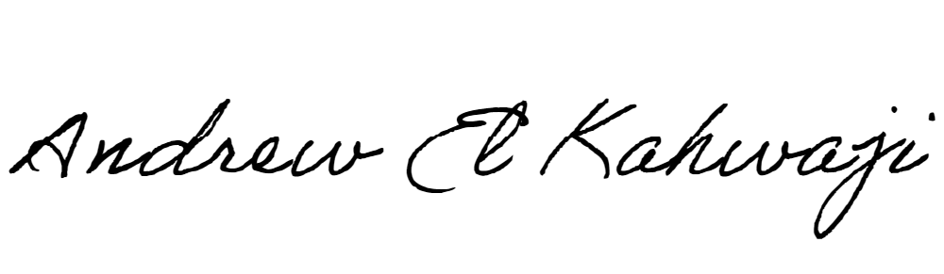

Printed Name _Andrew El Kahwaji_

Date __26/12/2024___

Email __andrew.lifesculptor.coo@gmail.com __

Phone __+961 71 914 378__